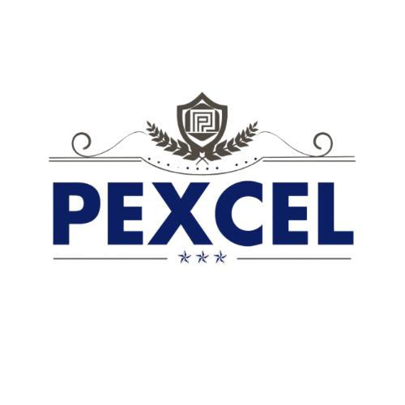
We specialize in high-quality colour, Additive, and Filler Masterbatches, designed to enhance the performance and aesthetics of plastic products across various industries. With innovation, sustainability, and customer satisfaction at our core, we deliver tailored solutions to meet your needs.

Explore our range of products and discover how we can add value to your business. Feel free to contact us for any inquiries!

